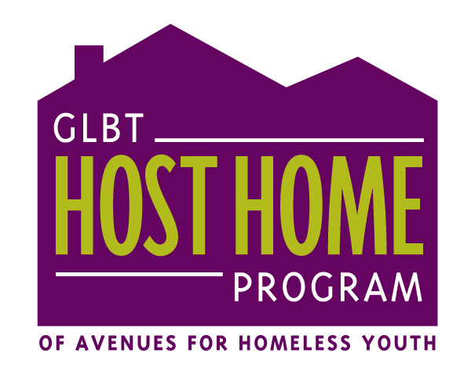
Case Manager Referral Form
(to be sent with Youth Application Form)

First, thank you for thinking of the GLBT HHP and supporting young people as they explore housing options. Below are some expectations we have about the referral process, as well as some guidelines for sharing relevant information. We encourage you to read this form with/to the young person. The main reason for doing this is to minimize the possibility of ‘setting-up’ youth and hosts. Thank you.
In Community – the GLBT HHP Team.

Guidelines for Disclosing Sensitive Information
and Case Manager Expectations

Disclosing sensitive information during the referral process:

Upon referring a youth, please take some time to think about and talk with your client about his/her/their readiness for the GLBT HHP. Here are some examples of issues that should be disclosed to the GLBT HHP Team throughout the referral process:

History of:

- Chemical Dependency
- Involvement in prostitution/survival sex/sex work/the sex trades
- Drug dealing
- Stealing
- Violence (physical, sexual, emotional)
- Mental Health issues
- Medical concerns (i.e. diabetes, asthma, allergies)

Because the GLBT HHP is meant to be a transition between homelessness and greater housing stability, it is crucial to assess the youth’s readiness and willingness to break away from – or at least not bring into the host home - activities/behaviors associated with street life. The issues listed above are all too present in the population of homeless youth – the GLBT HHP does NOT expect an absence of such issues. The GLBT HHP does, however, expect the youth to have already done some work around those issues. For example, a host home is very appropriate for someone who is needing/wanting a supportive environment around staying sober as one of his/her/their goals. It is NOT appropriate for someone who needs a place to get sober. Hosts are not trained to provide that kind of support.

When talking with a youth who is applying for the GLBT HHP, please discuss the fact that the youth application has a release of information statement at the bottom, which needs to be signed by that young person. Talk about what he/she/they think should be shared, what he/she/they is comfortable disclosing themselves to the GLBT HHP team, and what they would like you, as the referring case manager to disclose about their history. Also indicate the issues you think need to be talked about – issues that the youth may not have thought of or feels reluctant about sharing. These conversations will help you, the youth, and the GLBT HHP team figure out if the GLBT HHP is indeed the appropriate choice for your client. If the GLBT HHP is a good option for the youth, then these conversations will help us in matching your client to a host home and developing an effective goal plan.

Please be clear with the youth that the above information will be disclosed.

Disclosing sensitive information after the referral process:

The GLBT HHP will provide case management for your client while they are in a host home. However, in situations where the referring case manager has a well established relationship with, or has been providing intensive case management for the referred youth, the GLBT HHP requests that the referring case manager offer follow through and after-care through the first home visit, which is usually two weeks after the youth moves into a host home. After-care includes following up with a young person after they have moved into a host home. During your client’s transition into host home, you may learn information that needs to be shared with the GLBT HHP team and hosts. The issues we listed are examples of what MUST be discussed. Some behaviors associated with street life (such as dealing/using drugs) are not acceptable or viable in a host home. This does not mean that a youth is automatically out of the GLBT HHP if, for example, they are involved in sex work outside of the host home. If the youth is willing to address legitimate concerns that come up for us and/or the host(s), they could potentially remain in the host home. In order to assess your client’s willingness and readiness to stay, you must inform the GLBT HHP manager and set up a meeting for further discussion.

A lot of the behaviors associated with homelessness are, of course, survival skills. They have helped keep many young people alive. We are very aware that many of these ‘behaviors’ are reactions to systemic barriers that young people experience, especially GLBTQ youth of color.. Hopefully, the GLBT HHP can provide some youth with an opportunity to work on other skills and figure out what it means to live in a safer and caring environment, as defined by them.

I have read and understood the Guidelines for Disclosing Sensitive information
and understand my role as referring case manager.

Case Manager Signature __________________________________________________________

Name of youth/client ____________________________________________________ D.O.B. ____________________

Referring CM Name ______________________________________________________

Referring Agency _________________________________________________________

1.) How long have you been working with the young person?

2.) How often have you met/do you meet?

3.) How many conversations have you had with the young person about the GLBT HHP?

4.) We require that referring case managers check for outstanding citations/warrants. Have you done this? Are there any?

5.) Why do you feel that the GLBT Host Home Program would be a good fit for the young person?

6.) Are there any concerns regarding any of the following? (Mark all that apply, if there are concerns, these will be discussed via phone with a member of the GLBT HHP team)

- Chemical Dependency
- Involvement in prostitution/survival sex/sex work/the sex trades
- Drug dealing
- Stealing
- Violence (physical, sexual, emotional)
- Mental Health Issues
- Medical concerns (i.e. diabetes, asthma, allergies, etc)

Case Manager Signature ______________________________________________ Date _______________

