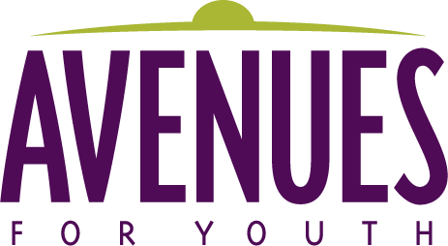

JOB TITLE: Assistant Director, Host Home and Collective housing

JOB SUMMARY: The Assistant Program Director is responsible for the general operations, services and outcomes of the community-based programs. The position provides leadership and support to the community-based programs by helping teach program to cultivate programming that is reflective of cultural awareness, youth determination and social justice advocacy and change.

REPORTS TO: Director of Programs

Avenues for Homeless Youth Community-Based housing provides emergency shelter, short-term housing, rapid re-housing and supportive services for youth and young families experiencing housing instability and homelessness. We strive to do that in a safe and nurturing environment through a social justice lens. Through such service, Avenues seeks to partner with youth and young families while they define their experiences, life dreams and future. Our work takes into account historical trauma, systems of oppression and intersectionality while being grounded in the power of resiliency, healing and community.

POSITION RESPONSIBILITIES
- Provide Program Managers with leadership and support, both in professional development as well as program development.
- Assist Program Managers with community engagement, locally, nationally and globally.
- Ensure that program values and expectations are clearly understood and followed by youth and staff
- Train and support staff in practicing principles-based work, including the following principles: trauma-informed, harm reduction, trusting relationships, strengths-based, journey-oriented, collaborative, non-judgmental, PYD, and holistic.
- Support staff in utilizing a social justice model that supports liberation and self-determination.
- Work with Director of Programs to help establish a research, evaluation and education institute. This includes creating an internal education institute to identify, train and support staff as needed, agency-wide and program specific.
- Work with Program Managers to create and sustain culturally appropriate models that re-enforce and move Avenues towards its mission, vision and values.
- Support outreach and community awareness to help sustain funding for each program.
- Work in partnership with Program Managers to create a program strategic plan that sustains program growth and viability.
- Assist Program Manager(s) with recruiting and strengthening how we recruit, screen, train and support hosts with an emphasis on hosts that are reflective of the communities served.
- Assist Program Manager(s) with engaging and strengthening how we connect with, screen, train and support Ubuntu with an emphasis on community members that are reflective of the communities served.
- Work in partnership with Program Managers to support Youth Advocate and Engagement Specialist, volunteers, interns and youth.
- Provide direct supervision of program evaluation and outcomes.
- Ensure the accurate and timely data entry into HMIS or other client data management system, if different.

QUALIFICATIONS: BA, BS or a Master’s degree in the field of human or social services, or other appropriate degree, plus 3 years of experience managing a program that supports youth who experience multiple systemic barriers. Experience with and commitment to principles-based youth work and restorative justice required. Understanding of power, privilege and systems of oppression required. Lived experiences and cross-transferable skills are welcomed and will be considered.
Avenues’ Assistant Director, will enjoy leading with a strong team approach, have excellent verbal and written communications skills, strong problem-solving and team-building abilities, a keen focus on the interests of the youth we support, computer proficiency, attention to detail, willingness to do paperwork and ensure all team members complete paperwork, and the desire and ability to take initiative and follow-through.
OTHER INFORMATION:
- Employment Status: Part-Time, Salaried, Exempt
- Hours: 24 hours per week, including some evening and weekend hours
- Location: Office will be at both the Brooklyn Park, North Minneapolis, and Camden location, but local travel will be required to other sites
- Compensation: Commensurate with qualifications and experience.

Persons of color are encouraged to apply.
Avenues for Youth is an Equal Opportunity Employer.

TO APPLY: Send cover letter, resume, references and salary requirements to Zayed Ahmed, Director of Programs at zahmed@avenuesforyouth.org or the address below. No phone calls please.

www.avenuesforyouth.org. • 1708 Oak Park Avenue North, Minneapolis MN 55411 • 612-522-1690

